|  |  |
| --- | --- |
| **Name:** | MANSI UNIYAL |
| **Roll Number:** | 19EE10039 |

**Experiment No. 5**

**Name of the Experiment: CAPACITIVE RECTIFICATION**

1. **Aim of the experiment**

* Learn Filtering of Rectified signal
* Ripple Voltage and Ripple Factor
* Learn Capacitive filtering

1. **Tools used:**

* Stimulation: Vlabs
* Breadboarding socket
* Oscilloscope
* Connecting Wires
* Diodes
* Sinusoidal input voltage source
* Load resistance
* Capacitor

1. **Background knowledge (brief):**

* Filter

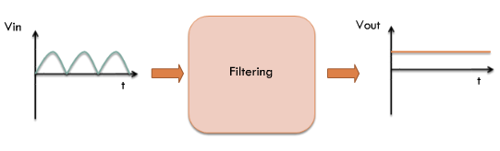

We have to convert the pulsating output of the rectifier to a constant DC supply. We have seen that the simplest kind of filter that can perform the filtering task just described is a capacitor. Thus, if we connect a capacitor directly across the output of a rectifier, the AC components will ‘see’ a low impedance path to ground and will not, therefore appear in the output.

* Ripple Voltage

For a finite capacitor, since a new charging pulse occurs every half cycle the capacitor charges and discharges very frequently. Smaller the Vpp, the more the waveform will resemble a pure DC voltage. The variable portion is known as ‘ripple’ and the value Vpp is known as the ripple voltage.

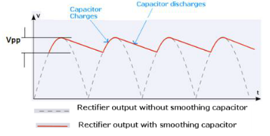

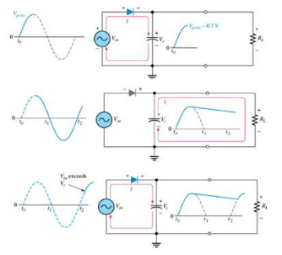

Since low ripple factors a desired, choosing a large capacitance value is not practical as they cost more and will create higher peak currents in the transformer secondary and in the supply feeding it.

1. **Circuit (hand drawn/image)**

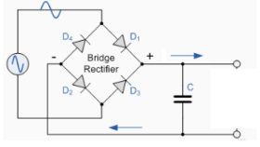

* **Half wave rectification**

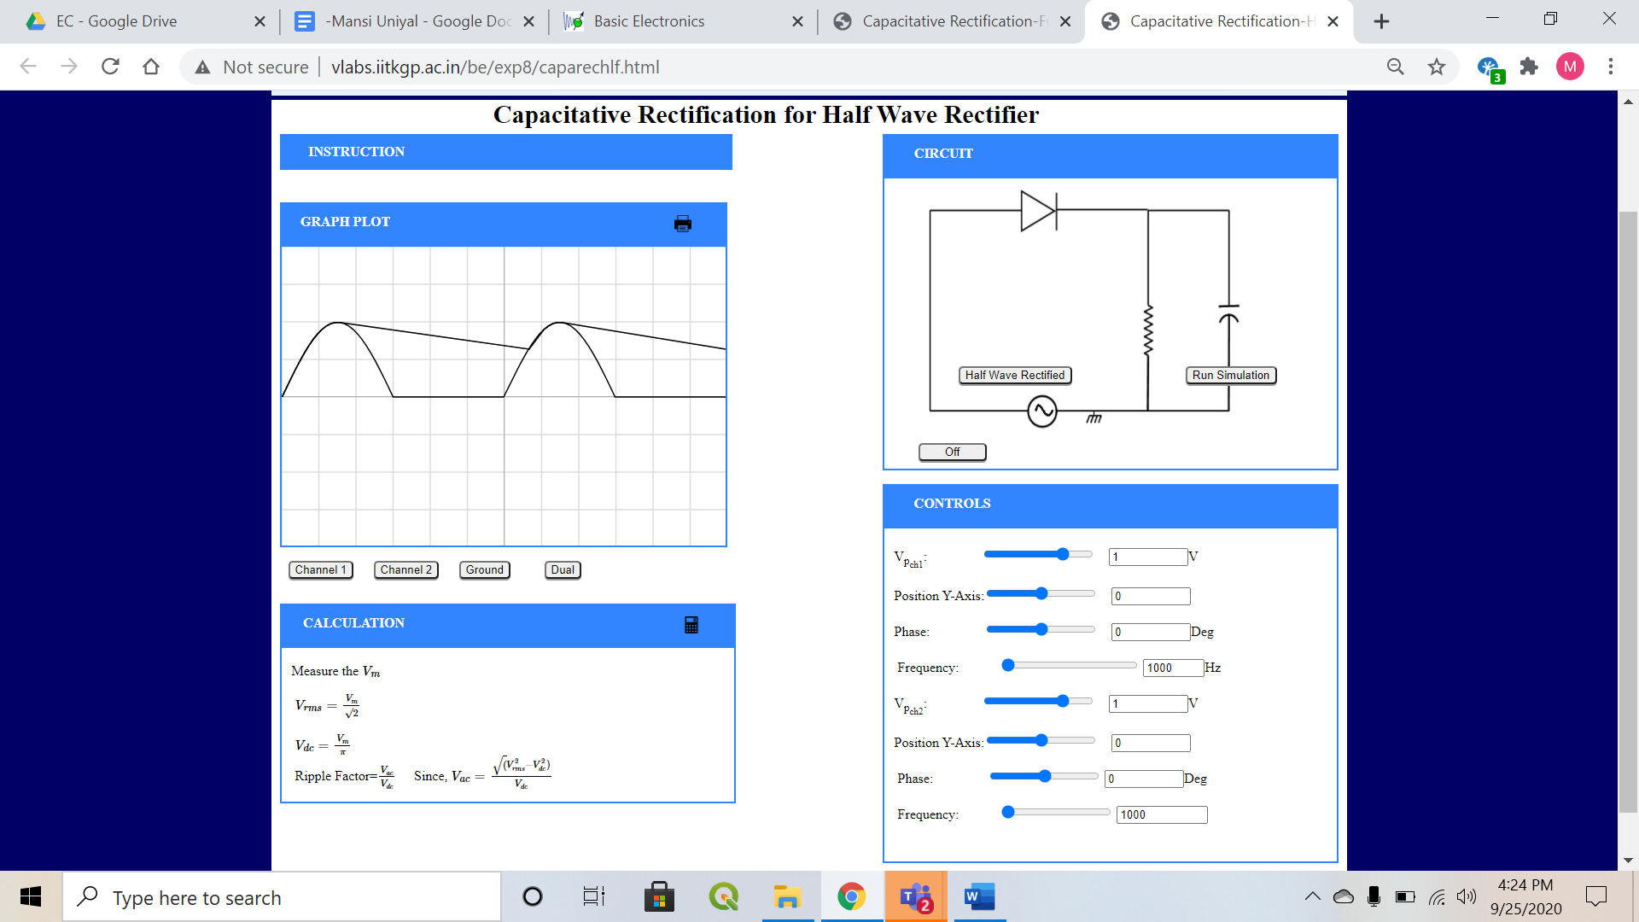

* **Full wave rectification**

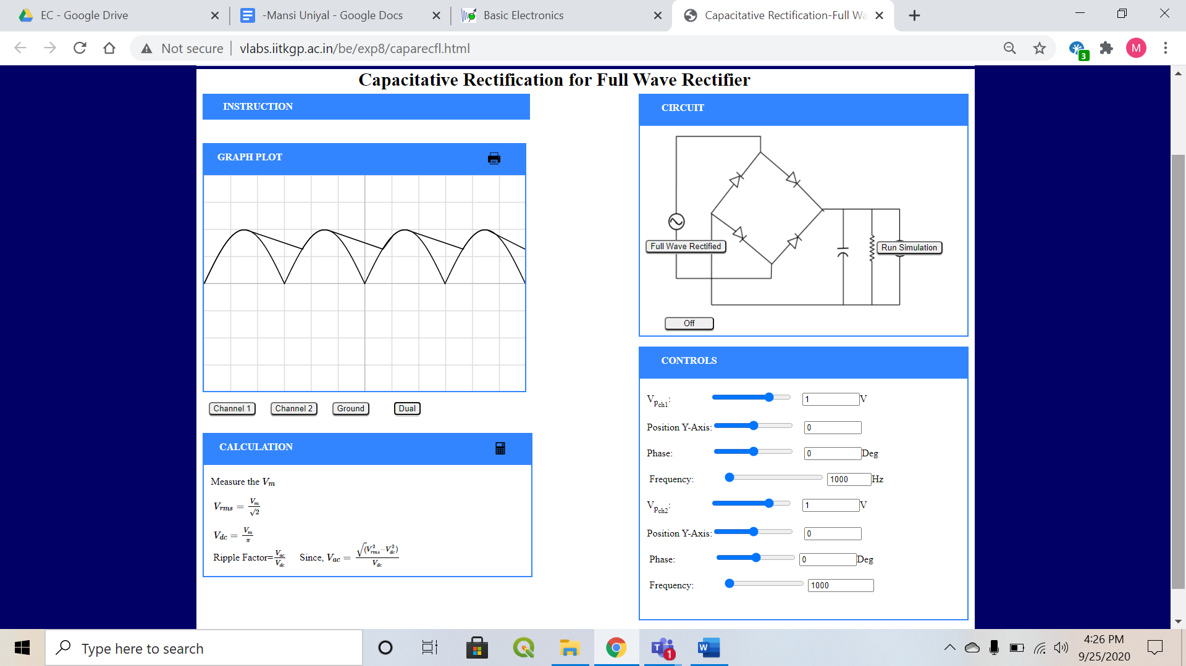

1. **Measurement Data (Tabular form)**



* **Half wave rectification**

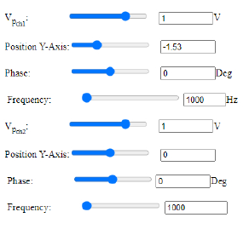

* **Full wave rectification**

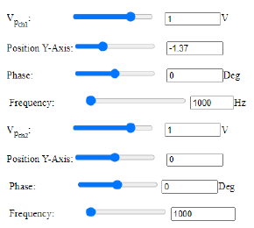

1. **Graph (Image)/Screenshots**

* **Half wave rectification**

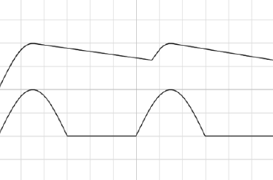

* **Full wave rectification**

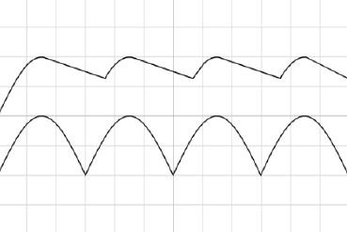

1. **Conclusion**
   * Filter 🡪
     + passes the dc component of the load
     + blocks the ac component of the rectifier output
   * Capacitive filtering 🡪 smooths DC output voltage
   * Capacitive filter on a full wave rectifier gives lesser ripple effect.
2. **Discussions**
   * Filter circuit can be made by the combination of
     + capacitors
     + resistors
     + inductors
   * Ripple Factor 🡪
     1. measure of effectiveness of a rectifier circuit
     2. ratio of RMS value of the AC component (ripple component) Irrms to the DC component IDC in the output waveform
   * Capacitor acts as a low-pass filter when used with a rectifier.
   * The capacitor can more effectively reduce the ripple when the time between peaks is shorter.
   * Capacitive filter is more effective on a full wave rectifier.

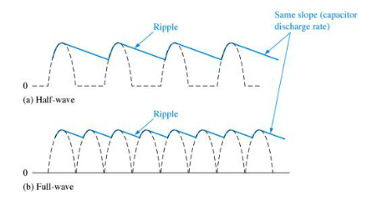

1. **Quiz**

